Party hats - will your party hat be funny or fantastic?
LO:
- to construct a basic headpiece from a paper strip using a stapler, scissors and a 'best fit' approach
- to carry out simple 'on to paper' decoration techniques - cutting and sticking (appliqué), attaching items using glue, tape or staples, drawing, colouring, controlled use of glitter (!)
- to listen to others and to contribute ideas to discussions
Design decisions:
- Appearance - overall nature of hat, e.g. crown, reindeer, snowstorm, starry night, Christmas decorations…
- Decoration - what is required to achieve the goal; the attachments and decorations needed.
- Construction - how will you add the decoration so that it achieves your aims and is durable.
Teaching:
Demo how to measure the right length for the strip of paper, mark it, cut it - they will staple it once it is decorated.
Display some pictures for theme ideas for their hats:
a snow scene, a starry night, a crown, decorations on a Christmas tree, a reindeer with antlers…
Show a selection of making materials on a table nearby (samples of paper, straws, glue, tape, scissors…) and lead a discussion about how they could be used to make a themed party hat…model some ideas as they occur,
e.g. by attaching straws to add height, for cutting paper shapes to stick on (appliqué), by folding paper into 6 to cut snowflakes, using a pentagon to create a star…
Remind them of careful selection of materials and thoughtful attaching - to create balance and possibly pattern, e.g. 'jewels' on a crown in a careful pattern. Also, not too much glue - they need to dry!

Success Criteria:
- The hat has a theme
- There is balance to the decoration
- The hat is durable
- The hat fits [and you can still see and eat]!
Making session!
Provide support as needed.
Help to staple once finished.
Verbally evaluate the designs:
- Does your hat meet the success criteria?
- What challenges did you overcome?
- What did you find easy?
- Did anything go wrong?
- Have you learned any new skills?
- What did you enjoy the most?
- Did you help each other?
- How would you approach the task if you were to do it again?
Possible extension:
How should you move to reflect the theme of your hat?
What sound effects should your hat have?

Useful images follow
Ideas adapted from Nuffield Foundation 2001, Design and Technology


white silhouette

golden shiny
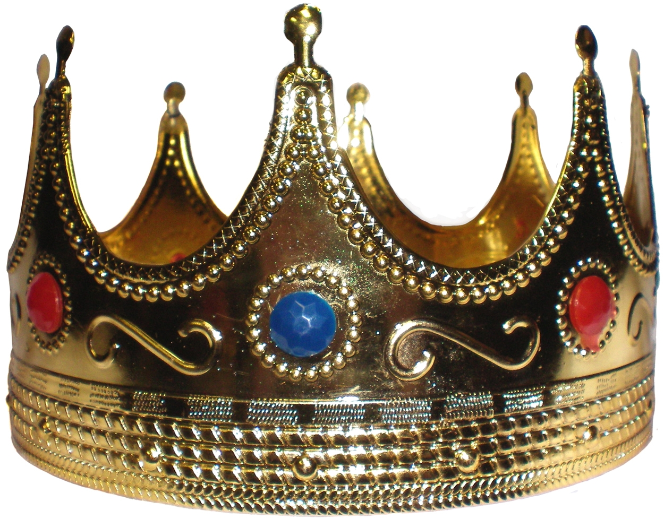
jewels symmetry pattern 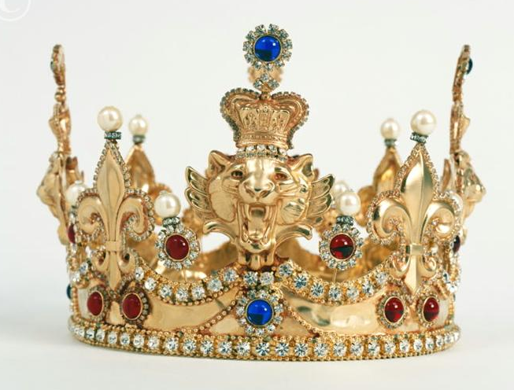


antlers ears eyes muzzle
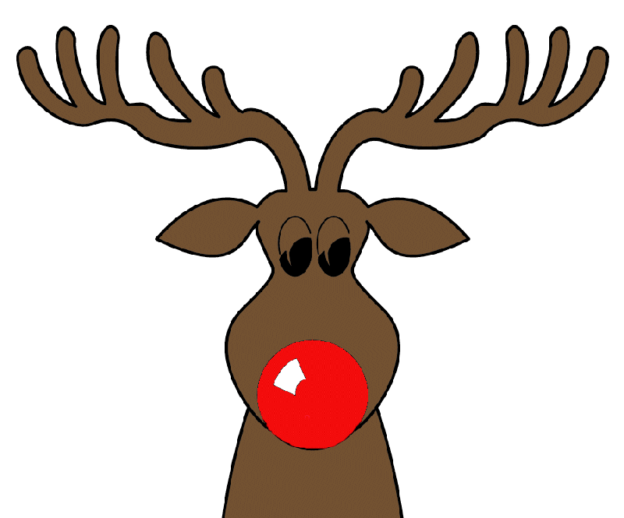
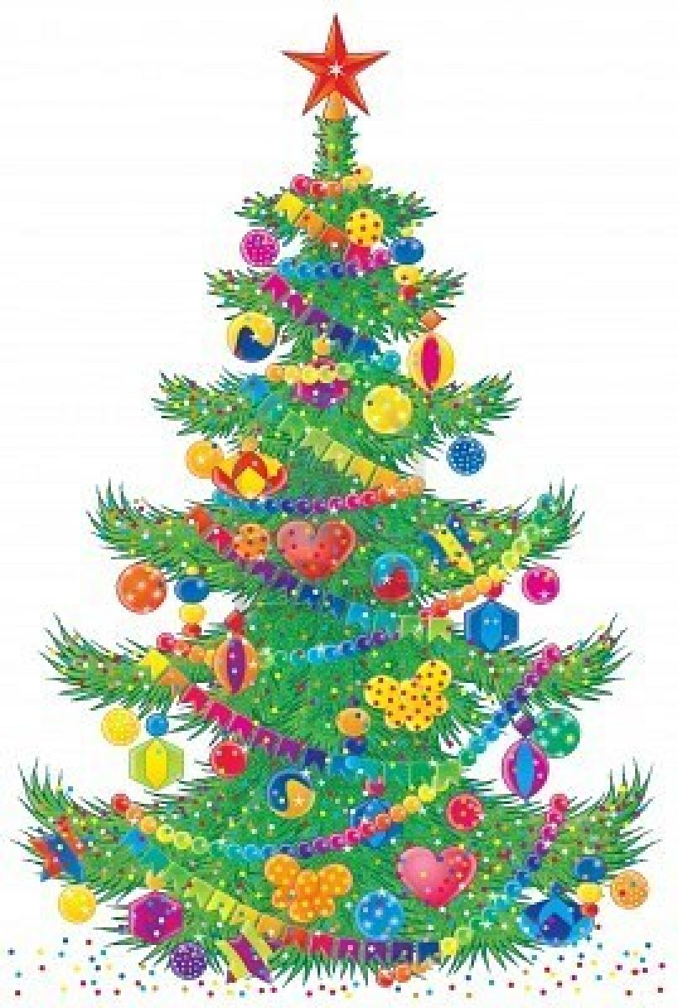
baubles chains stars hearts
colourful

round pattern ribbon sparkle


